National Tsing Hua University NPIE Bridge Program will showcase academic research achievements at InnoVEX 2017

New Intelligent Technologies, Bridging Innovative Generation, Pioneering New era

NPIE Bridge Program is continuously promoting the prospective research achievements of academia team and offering industry-academic cooperative platform. It promotes industry-academic cooperative achievements at InnoVEX 2017. There are 4 technological teams being accompanied by the NPIE office to attend InnoVEX 2017(stalls: G0362) at World Trade Center 3. To represent the most popular technologies as Artificial intelligence, Autopilot and Intelligent healthcare needs, we show the innovative technologies of Deep Learning Based on ADAS System, e-Bus - Rhythm and HR Monitor, CAN Bus OBDII Bridge and Intelligent Healthcare Watch. Welcome to visit and discuss further cooperation.

Except perform research and competitive achievements of academia in this exhibition, we are looking forward to discussing with seniors of industry more. By promoting industry-academia cooperation and technology transfer further, to realize prospective technologies in benefits of industrial application. Our teams have new creation wills to Welcome VC’s guidance. Since some of our academic research team had established a startup. If there are some chances to raise Venture capital Angel funds for operational requirements, it will enlarge the possibility of mass production.
We are welcoming all of you to visit.

The National Program for Intelligent Electronics (NPIE) was inaugurated by the Taiwan government in 2011. After five-year execution, the NPIE Bridge Program was proposed and approved by the Ministry of Science and Technology. The NPIE Bridge Program aims at transferring the NPIE's R&D results into industrial applications and achieving economic and social benefits, and thus aligns with the vision of NPIE-Intelligent Electronics for a Better Life and a Better Environment. The objectives of this program include:
‧to spread academic results into real industry applications
‧to create a new era of innovative industry-academia collaboration
‧to deploy technology advantages and foresee IP values
‧to promote R&D capabilities to the global stage
‧to cultivate entrepreneurship and promote startups
‧to maintain competitiveness of Taiwan semiconductor industry

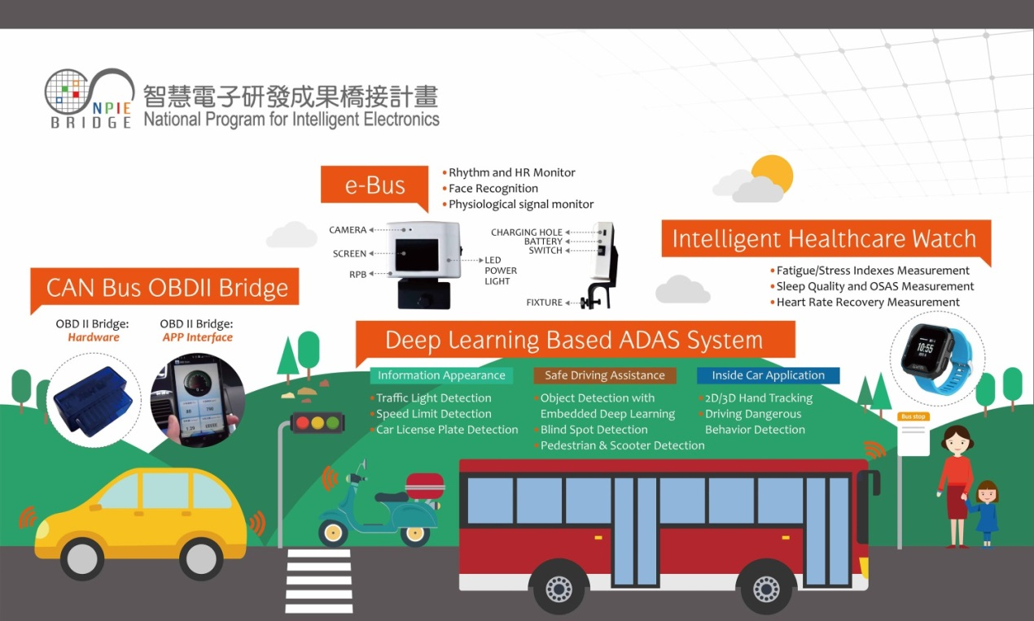

NPIE Bridge Program will showcase four techniques including Deep Learning Based on ADAS System, e-Bus, CAN Bus OBDII Bridge and Intelligent Healthcare Watch. There is the brief introduction of our technologies as below:

NCTUiVSIAC - Deep Learning Based ADAS System
NCTUiVSIAC provides professional and innovative vision-based software solutions to driving assistance, surveillance, and medical video application field for industry, including Wide-view stitching, 360-degree video stitching, Inclement weather processing, Single-camera/ Dual-camera/ Camera-array HDR night vision, Local HDR night vision, Forward collision warning, Lane departure warning (ISO-17361 certificated), Pedestrian and scooter detection, Blind spot detection, Speed limit sign detection, Triangular sign detection, etc. Now, we have developed efficient deep-learning-based solutions for FCWS, Pedestrian detection, vehicle detection, motorcycle rider/bicycle rider detection and BSD that could be realized in an embedded system (nVidia Jetson TX-1) in real-time.

e-Bus - Rhythm and HR Monitor
We are committed to guarantee the lives and property of motorists all over the world by providing stronger protection. Our team develop the product, eBus, which is symbolized to equip a substantial armor for all users to avoid drivers from traffic accidents. "eBus", a mobile device application, is essentially a security monitoring system with computer vision technology. Combined with physiological signals measuring, driving behavior analysis, fatigue driving and expression analysis, eBus could effectively monitor the stability of the driver's health, facial expression, and behavior state, and analyze whether there is a dangerous driving action, etc. In dangerous situation, it will give a warning immediately, or send a request message to prevent from the traffic accident. Furthermore, eBus could be integrated with other Advanced Driver Assistance Systems (ADAS), and aggregates internal (such as the driver's state) and external (such as road information and road conditions) information of a moving vehicle so that the system will be much stronger to enhance the car safety.

SWISYS - CAN Bus OBDII Bridge
V-Bridge is a vehicle diagnostics and data collection solution connecting drivers (and or UBI insurers) to their cars through our cost efficient hardware and customer-centric software (both developed in-house). Data collected is stored in a cloud server for further application & service extensions.

ZOETEK INC. - (Health Watch)
Zoetek’s stock code is 7506 which is a company certified ISO 13485 medical devices quality management system. Zoetek is a startup company transferred key technologies of Medical Engineering Lab in NTUT and funded by alumnus of NTUT.
Zoetek is located in the Innovation and Incubation Center in National Taipei University of Technology (NTUT) which works hard and makes lots of efforts in commercialization of wearable medical devices. With aggressive patents layout in application of multiple physiological parameters algorithm, Zoetek has got 14 patents in four countries and grasped the development of key module (Optical Bio-sensor Module). Among them, the key module is collaboratively developed by Taiwan's photovoltaic and IC design firms, then Zoetek integrates algorithms.
Zoetek is now forward to be main in getting certification of FDA medical devices by wearable health medical devices, developping Health Watch and integrating elder age residences, homecare centers, medical agents and healthcare centers. Zoetek offers comprehensive perfect healthcare system.

Contact Information
NPIE Bridge Program@InnoVEX
Booth No.：G0362@TWTC Hall3
Tel：03-5162252 Ms. Cheng
E-mail：chengyj@mx.nthu.edu.tw
Organize by：NPIE Bridge Program
Co-organizer：NCTUiVSIAC, e-Bus, SWISYS CO.,Ltd, ZOETEK INC.

