InnoVEX 2017 Exhibitor News – NextDrive

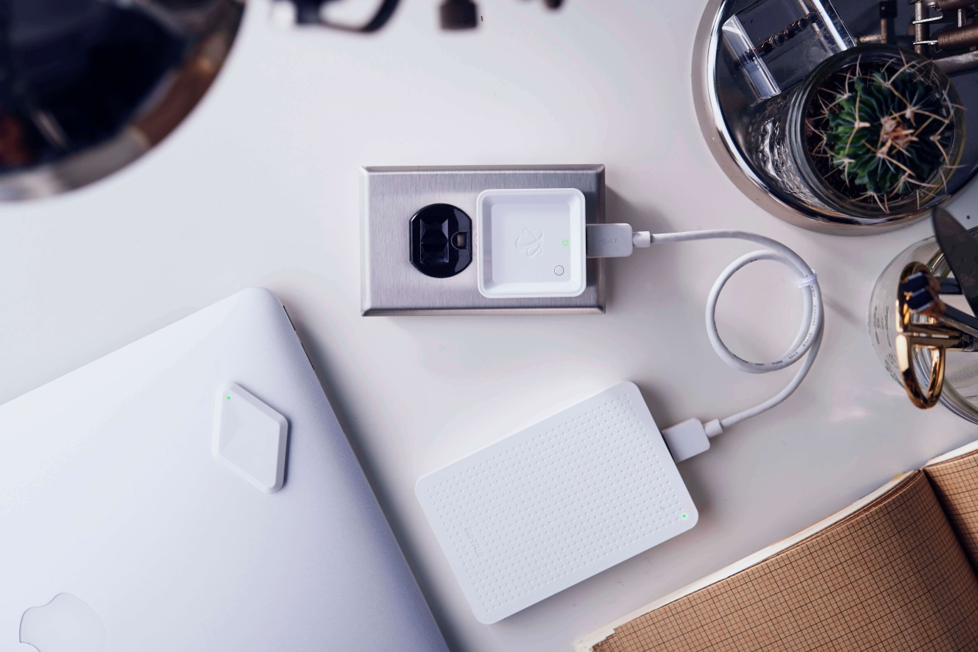

NextDrive, established in 2013, is a Taiwanese startup that focuses on IoT for homes and individuals. Since its establishment, it has received many international and local awards and media coverage, awards including IDEAS Show Awards, Fukuoka Global Venture Awards, etc. In 2015, funding platform Indiegogo launched NextDrive Plug and received the support of nearly thousands of consumers.

In 2016, NextDrive launched NextDrive Cube, which is the world’s smallest IoT gateway to date. NextDrive Cube is compatible with 720P high-definition “Wide-Angel Webcam,” “Motion Pixi,” and “Thermo Pixi,” allowing users to easily monitor their homes. The setup is also quite simple- it can be done in less than one minute!

Under Taipei Computer Association’s promotion, NextDrive collaborated with Japan’s IIJ (Internet Initiative Japan), and semiconductor manufacturer ROHM, and will begin to sell “NextDrive Wi-SUN Cube” in April, targeting the Japanese market. This product is the IoT core of the “Home Energy Manager Service.” Japanese consumers can get a hold of their power usage and control their electronics just by using their smart phones.

A special highlight of this year is that NextDrive will exhibit the world’s smallest 32-Bit/384kHz portable DAC headphone amp, Spectra. With its ESS 9018Q2C DAC chip, Spectra is best-in-class, providing HiFi music-lovers unprecedented dynamic range, ultra low distortion, and high quality audio on-the-go.

