InnoVEX 2017 Exhibitor News – Air Mentor Intelligence Corp.

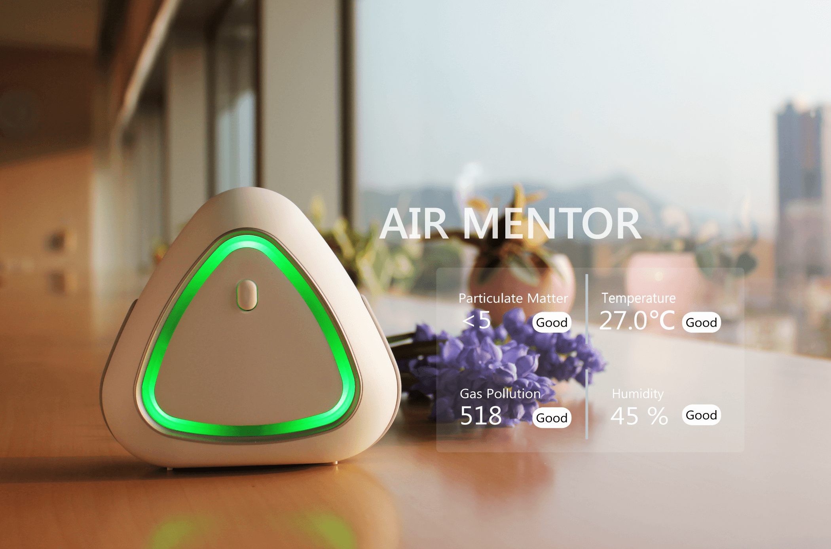

Established in January 2017, Air Mentor Intelligence Corp. (AMIC), a subsidiary of CoAsia Microelectronics Corp., focuses on IoT environmental detection and artificial intelligence technology. Air Mentor is set on resolving air quality problems and works closely with its partners to come up with highly effective solutions that reduce the threats air pollutions pose.

For the past couple of years, people have started to turn their attention to indoor air quality. Therefore, AMIC launched AIR MENTOR PRO as an indoor air quality solution. AIR MENTOR PRO can detect CO2, CO, total Volatile organic compounds (TVOC), fine particles (PM2.5/PM10), temperature, and humidity within 711.8 square feet. Presently, AMIC’s customers are mainly from medical and manufacturing fields, and while the main market is in Taiwan, AMIC will expand its market to Southeast Asia in the near future.

AMIC stated that not too many companies have combined detectors and air purifiers. AMIC is the first in Taiwan to do so. AIR MENTOR PRO can provide users real-time suggestions by using Big Data analysis, which is currently stored in AWS Cloud system, and can help them easily detect and improve indoor air quality to ensure their bodies are not affected by air pollutants.

Unlike other air quality detectors, AMIC uses industrial-grade sensors with numerous detailed tuning and environmental testing, their accuracy comparable to professional laboratory equipment. Each sensor is calibrated in the production line and tested in specific gas chambers to ensure that the sensor readings are consistent.

Booth Number: G0634

