ASUS Glamorfy AR Kiosk
International Data Corporation's (IDC) latest report reveals that global revenues from augmented (AR) and virtual reality (VR) will grow to more than $162 billion by 2020 - a CAGR of just over 181%. In Q4 2017, Apple will officially announce iPhone 8 with AR function, and Microsoft will release HDM+ MR Ready PC hardware platform. To provide the whole new shopping experience using AR technology, Alibaba's Jack Ma frequently highlighted his new retail concept and Amazon launched Amazon Go convenience store with no checkout required.

ASUS Glamorfy has been developing augmented reality (AR) technology for several years. Now key functions are highlighted: real-time makeup simulation, virtual accessory try-on (glasses, jewelry, and shoes), and 3D bases SLAM algorithm for industry 4.0.
Here is Glamorfy AR features list:
1. Real-time beautification and cosmetic simulation
2. Real-time contact lens simulation
3. Glasses/ Sunglasses virtual wearing and 3D size measurement
4. Shoes virtual try-on
5. Integration with VoIP functions for online chatting (Skype, LINE, QQ, ect.)
6. Biological characteristics detection for big data analysis and customized service

For more information, please visit Glamorfy Facebook fan page:
www.facebook.com/glamorfy
- Glamorfy Cosmetic AR Kiosk
2. Glamorfy Contact Lens Virtual Simulation Kiosk
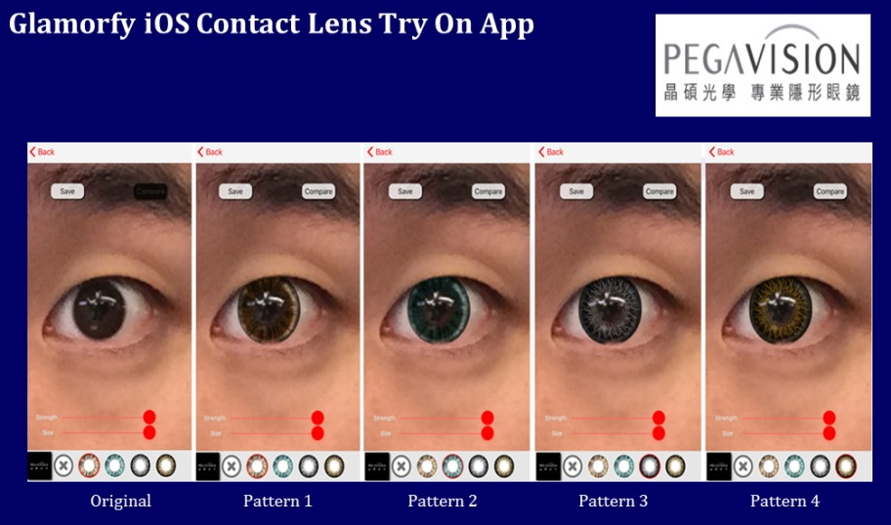
3. Glamorfy Glasses Virtual Wearing
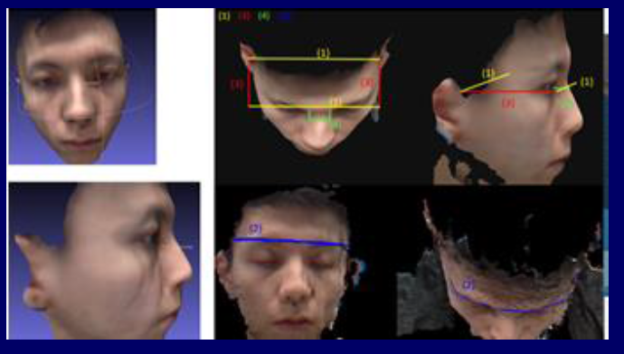
4. Glamorfy Shoes AR Kiosk
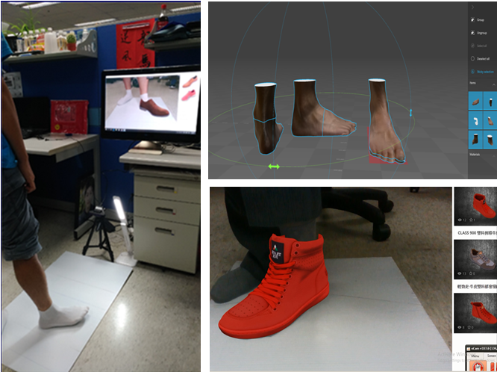
Glamorfy Booth number: G0120, Hall 3

